]SCHOOL OF COMPUTER SCIENCE AND ARTIFICIAL INTELLIGENCE |  |  |  |  | DEPARTMENT OF COMPUTER SCIENCE ENGINEERING
ProgramName:M. Tech |  |  |  | Assignment Type: Lab |  |  | AcademicYear:2025-2026
CourseCoordinatorName |  |  |  | Venkataramana Veeramsetty
rCourseCode |  |  | 24CS002PC215 | CourseTitle |  | AI Assisted Problem Solving Using Python
Year/Sem |  |  | II/I | Regulation |  | R24
Date and Day  of Assignment |  |  | 10.11.2025 | Time(s)
Duration |  |  | 2 Hours | Applicableto  Batches
AssignmentNumber:9.3(Present assignment number)/24(Total number of assignments)
 | Q.No. | Question |  |  |  |  |  | ExpectedTime  to complete
 | 1 | Lab 9: Documentation Generation: Automatic documentation and code comments  Lab Objectives:  - To understand the importance of documentation and code comments in software development.  - To explore how AI-assisted coding tools can generate meaningful documentation and inline comments.  - To practice generating function-level and module-level docstrings automatically.  - To evaluate the quality, accuracy, and limitations of AI-generated documentation.  - To develop a small automated tool for documentation generation in Python..  Lab Outcomes (LOs):  After completing this lab, students will be able to:  - Apply AI-assisted coding tools to generate docstrings and inline comments for Python code.  - Critically analyze AI-generated documentation for correctness, completeness, and readability.  - Create structured documentation (function-level, module-level) following standard formats.  - Design and implement a mini documentation generator tool to automate code commenting and docstring creation.  Task Description#1 Basic Docstring Generation  - Write python function to return sum of even and odd numbers in the given list.  - Incorporate manual docstring in code with Google Style  - Use an AI-assisted tool (e.g., Copilot, Cursor AI) to generate a docstring describing the function.  def sum_even_odd(numbers):  """  MANUALLY WRITTEN DOCSTRING (Google Style)  ==========================================  Calculates the sum of even and odd numbers in a given list.  Args:  numbers (list[int]): A list of integers to process.  Returns:  tuple: A tuple containing two integers:  - Index 0: The sum of all even numbers in the list.  - Index 1: The sum of all odd numbers in the list.  Raises:  TypeError: If the input is not a list or contains non-integer values.  Example:  >>> sum_even_odd([1, 2, 3, 4, 5])  (6, 9)  >>> sum_even_odd([10, 20, 30])  (60, 0)  """  even_sum = sum(num for num in numbers if num % 2 == 0)  odd_sum = sum(num for num in numbers if num % 2 != 0)  return even_sum, odd_sum  def sum_even_odd_v2(numbers):  """  AI-GENERATED DOCSTRING (GitHub Copilot Style)  ===============================================  Computes the sum of even and odd numbers from a list.  This function iterates through a list of integers and partitions them  into two groups: even numbers and odd numbers. It returns the sum of  each group as a tuple.  Args:  numbers: A list containing integer values to be processed.  Returns:  A tuple of two integers where the first element is the sum of even  numbers and the second element is the sum of odd numbers.  Examples:  >>> sum_even_odd_v2([1, 2, 3, 4, 5])  (6, 9)  >>> sum_even_odd_v2([2, 4, 6])  (12, 0)  >>> sum_even_odd_v2([1, 3, 5])  (0, 9)  """  even_sum = sum(num for num in numbers if num % 2 == 0)  odd_sum = sum(num for num in numbers if num % 2 != 0)  return even_sum, odd_sum  # ============================================================================  # DOCSTRING COMPARISON ANALYSIS  # ============================================================================  """  MANUAL DOCSTRING vs AI-GENERATED DOCSTRING  1. STRUCTURE & FORMAT  Manual: Concise, follows strict Google Style format  AI: Slightly more verbose, includes descriptive narrative paragraph  2. CLARITY & DESCRIPTIONS  Manual: Direct and to-the-point with clear type annotations  AI: Adds contextual explanation of what the function does (iteration, partitioning)  3. ARGS SECTION  Manual: Includes type hint [list[int]] with brief description  AI: Simpler, just mentions "list containing integer values"  4. RETURNS SECTION  Manual: Explicitly states Index 0 and Index 1 with descriptions  AI: More descriptive narrative format, less explicit index notation  5. EDGE CASES  Manual: Includes Raises section for TypeError (defensive programming)  AI: No error handling documentation  6. EXAMPLES  Manual: 2 examples showing basic and edge cases (all even numbers)  AI: 3 examples showing basic, all even, and all odd cases  7. OVERALL ASSESSMENT  Manual: More structured, defensive, follows strict format  AI: More narrative and educational, easier to understand context  Best Practice: Use manual as base (more specific types, error handling)  but incorporate AI's narrative style for clarity  """  # ============================================================================  # TEST CASES  # ============================================================================  if __name__ == "__main__":  # Test case 1: Mixed even and odd numbers  test1 = [1, 2, 3, 4, 5]  result1_manual = sum_even_odd(test1)  result1_ai = sum_even_odd_v2(test1)  print(f"Test 1 - Input: {test1}")  print(f" Manual Docstring Result: {result1_manual}")  print(f" AI Docstring Result: {result1_ai}")  print(f" Match: {result1_manual == result1_ai}\n")  # Test case 2: All even numbers  test2 = [10, 20, 30]  result2_manual = sum_even_odd(test2)  result2_ai = sum_even_odd_v2(test2)  print(f"Test 2 - Input: {test2}")  print(f" Manual Docstring Result: {result2_manual}")  print(f" AI Docstring Result: {result2_ai}")  print(f" Match: {result2_manual == result2_ai}\n")  # Test case 3: All odd numbers  test3 = [1, 3, 5, 7]  result3_manual = sum_even_odd(test3)  result3_ai = sum_even_odd_v2(test3)  print(f"Test 3 - Input: {test3}")  print(f" Manual Docstring Result: {result3_manual}")  print(f" AI Docstring Result: {result3_ai}")  print(f" Match: {result3_manual == result3_ai}\n")  # Test case 4: Empty list  test4 = []  result4_manual = sum_even_odd(test4)  result4_ai = sum_even_odd_v2(test4)  print(f"Test 4 - Input: {test4}")  print(f" Manual Docstring Result: {result4_manual}")  print(f" AI Docstring Result: {result4_ai}")  print(f" Match: {result4_manual == result4_ai}\n")  # Test case 5: Negative numbers  test5 = [-2, -1, 0, 1, 2]  result5_manual = sum_even_odd(test5)  result5_ai = sum_even_odd_v2(test5)  print(f"Test 5 - Input: {test5}")  print(f" Manual Docstring Result: {result5_manual}")  print(f" AI Docstring Result: {result5_ai}")  print(f" Match: {result5_manual == result5_ai}")  - Compare the AI-generated docstring with your manually written one.  Expected Outcome#1: Students understand how AI can produce function-level documentation.  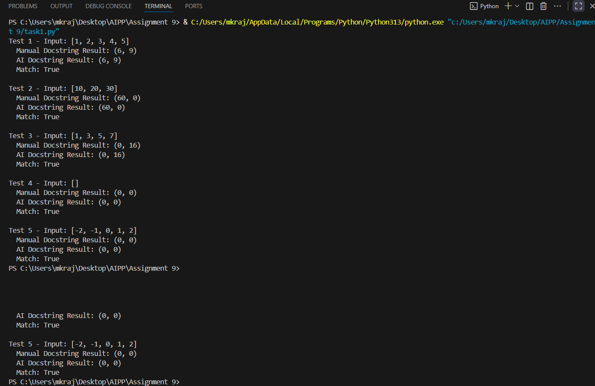  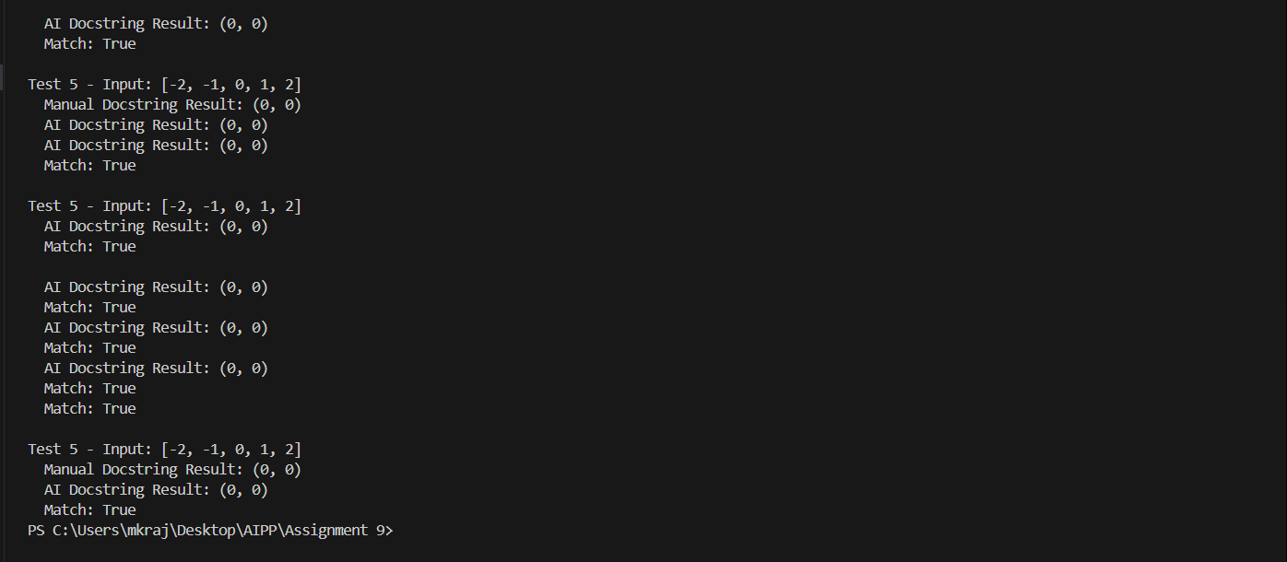  Task Description#2 Automatic Inline Comments  - Write python program for sru_student class with attributes like name, roll no., hostel_status and fee_update method and display_details method.  - Write comments manually for each line/code block  - Ask an AI tool to add inline comments explaining each line/step.  - Compare the AI-generated comments with your manually written one.  # ============================================================================  # TASK 2: SRU_STUDENT CLASS WITH MANUAL COMMENTS  # ============================================================================  # Define the sru_student class to manage student information and operations  class sru_student:  # Class variable to track the number of students created  student_count = 0  # Initialize the student object with personal and academic details  def __init__(self, name, roll_no, hostel_status):  # Store the student's full name as an instance variable  self.name = name  # Store the student's roll number for identification  self.roll_no = roll_no  # Store hostel status (True if in hostel, False otherwise)  self.hostel_status = hostel_status  # Initialize the total fees as 0  self.total_fees = 0  # Increment the student count whenever a new student is created  sru_student.student_count += 1  # Method to update the fees and add additional charges based on hostel status  def fee_update(self, base_fee):  # Set the base tuition fee for the student  self.total_fees = base_fee  # Check if student is living in hostel  if self.hostel_status:  # Add hostel charges of 5000 to total fees if student is in hostel  self.total_fees += 5000  # If student is not in hostel, add transportation charges  else:  # Add transportation charges of 2000 for day scholars  self.total_fees += 2000  # Return the updated total fees for confirmation  return self.total_fees  # Method to display all student details in a formatted manner  def display_details(self):  # Print a formatted header for student details  print("\n" + "="*50)  print("STUDENT DETAILS")  print("="*50)  # Display the student's name  print(f"Name: {self.name}")  # Display the student's roll number  print(f"Roll No: {self.roll_no}")  # Check hostel status and display appropriate message  hostel_info = "Yes (In Hostel)" if self.hostel_status else "No (Day Scholar)"  # Display the hostel status with readable format  print(f"Hostel Status: {hostel_info}")  # Display the total fees charged to the student  print(f"Total Fees: Rs. {self.total_fees}")  # Print a bottom border for formatting  print("="*50 + "\n")  # Class method to display total number of students  @classmethod  def display_student_count(cls):  # Print the total count of student objects created  print(f"Total Students Registered: {cls.student_count}")  # ============================================================================  # DEMONSTRATION AND TEST CASES  # ============================================================================  if __name__ == "__main__":  # Create first student object with name, roll number, and hostel status  student1 = sru_student("Raj Kumar", 101, True)  # Update fees for student1 with base fee of 50000  student1.fee_update(50000)  # Display all details of student1  student1.display_details()  # Create second student object who is a day scholar  student2 = sru_student("Priya Singh", 102, False)  # Update fees for student2 with base fee of 50000  student2.fee_update(50000)  # Display all details of student2  student2.display_details()  # Create third student object  student3 = sru_student("Anita Sharma", 103, True)  # Update fees for student3 with base fee of 50000  student3.fee_update(50000)  # Display all details of student3  student3.display_details()  # Display the total count of all students created  sru_student.display_student_count()  # ============================================================================  # AI-GENERATED COMMENTS (GitHub Copilot Style)  # ============================================================================  class sru_student_ai:  """Student class with AI-generated inline comments"""  # Tracks total number of student instances  student_count = 0  def __init__(self, name, roll_no, hostel_status):  # Assign the name parameter to the instance  self.name = name  # Assign the roll number parameter to the instance  self.roll_no = roll_no  # Assign the hostel status boolean to the instance  self.hostel_status = hostel_status  # Initialize fees to zero  self.total_fees = 0  # Increment the class-level student counter  sru_student_ai.student_count += 1  def fee_update(self, base_fee):  # Update the total fees with the base fee amount  self.total_fees = base_fee  # If student lives in hostel, add hostel charges  if self.hostel_status:  # Add 5000 rupees for hostel accommodation  self.total_fees += 5000  else:  # Add 2000 rupees for daily transportation  self.total_fees += 2000  # Return the calculated total fees  return self.total_fees  def display_details(self):  # Create a horizontal separator line for visual formatting  print("\n" + "="*50)  # Display the section title  print("STUDENT DETAILS")  # Print the separator again  print("="*50)  # Output the student's name  print(f"Name: {self.name}")  # Output the student's roll number  print(f"Roll No: {self.roll_no}")  # Determine hostel status text based on boolean value  hostel_info = "Yes (In Hostel)" if self.hostel_status else "No (Day Scholar)"  # Output the hostel status with descriptive text  print(f"Hostel Status: {hostel_info}")  # Output the total calculated fees  print(f"Total Fees: Rs. {self.total_fees}")  # Print the closing separator line  print("="*50 + "\n")  @classmethod  def display_student_count(cls):  # Print the total count of created student instances  print(f"Total Students Registered: {cls.student_count}")  # ============================================================================  # COMPARISON ANALYSIS: MANUAL vs AI-GENERATED COMMENTS  # ============================================================================  comparison_analysis = """  MANUAL COMMENTS vs AI-GENERATED COMMENTS  1. COMMENT STYLE & TONE  Manual:  - Descriptive and contextual, explains WHY code does something  - Uses conversational language  - Provides business logic context  AI:  - Concise and technical, explains WHAT code does  - More straightforward and action-oriented  - Focuses on direct operations  2. LEVEL OF DETAIL  Manual:  - More verbose, provides reasoning and flow  - Example: "Check if student is living in hostel" + reason  - Includes explanations of outcomes  AI:  - Minimal but complete, no redundancy  - Example: "If student lives in hostel, add hostel charges"  - Direct action-oriented statements  3. CLARITY FOR BEGINNERS  Manual:  - Better for learning code logic and business requirements  - Explains both HOW and WHY  - Example: "Add hostel charges of 5000 to total fees if student is in hostel"  AI:  - Good for understanding code flow quickly  - Explains WHAT happens at each step  - Example: "Add 5000 rupees for hostel accommodation"  4. CODE MAINTENANCE  Manual:  - Easier to understand original intent  - Better for future modifications  - Helps identify business logic changes  AI:  - Easier to read for experienced developers  - Less clutter in code  - Still clear for debugging  5. SPECIFIC OBSERVATIONS  a) Initialization (__init__)  Manual: "Store the student's full name as an instance variable"  AI: "Assign the name parameter to the instance"  Winner: Manual (explains purpose, not just action)  b) Fee Calculation  Manual: "Add hostel charges of 5000 to total fees if student is in hostel"  Explicitly mentions the amount and reason  AI: "Add 5000 rupees for hostel accommodation"  Mentions amount but less context about total fees  Winner: Manual (more complete context)  c) Hostel Status Display  Manual: "Check hostel status and display appropriate message"  + "Display the hostel status with readable format"  AI: "Determine hostel status text based on boolean value"  + "Output the hostel status with descriptive text"  Winner: AI (more concise, equally clear)  d) Class Variables  Manual: "Class variable to track the number of students created"  AI: "Tracks total number of student instances"  Winner: Manual (slightly more descriptive)  6. REDUNDANCY  Manual:  - Some redundant comments (e.g., multiple lines explain same thing)  - Could be consolidated for better readability  AI:  - Minimal redundancy  - Every comment adds new information  7. BEST PRACTICES INSIGHTS  For Production Code:  - Use AI-generated style (less verbose, faster to read)  - But include reasoning comments for complex logic  For Educational Code:  - Use manual style (explains context and purpose)  - Helps learners understand not just HOW but WHY  For Team Development:  - Use a hybrid approach:  * AI-style for straightforward operations  * Manual-style for business logic and complex algorithms  8. OVERALL RECOMMENDATION  Hybrid Approach:  ✓ Use manual comments for business logic and algorithms  ✓ Use AI-style comments for straightforward operations  ✓ Combine them for maximum clarity and efficiency  Manual comments are better for:  - Teaching and learning  - Complex business logic  - Future maintenance and understanding intent  AI-generated comments are better for:  - Code readability for experienced developers  - Reducing comment clutter  - Faster code reviews  9. KEY TAKEAWAY  AI-generated comments are technically accurate and useful, but they lack  the contextual understanding of WHY code exists. Manual comments provide  this crucial context, especially for educational and team environments.  The ideal solution combines both approaches strategically.  """  print(comparison_analysis)  Expected Output#2: Students critically analyze AI-generated code comments.  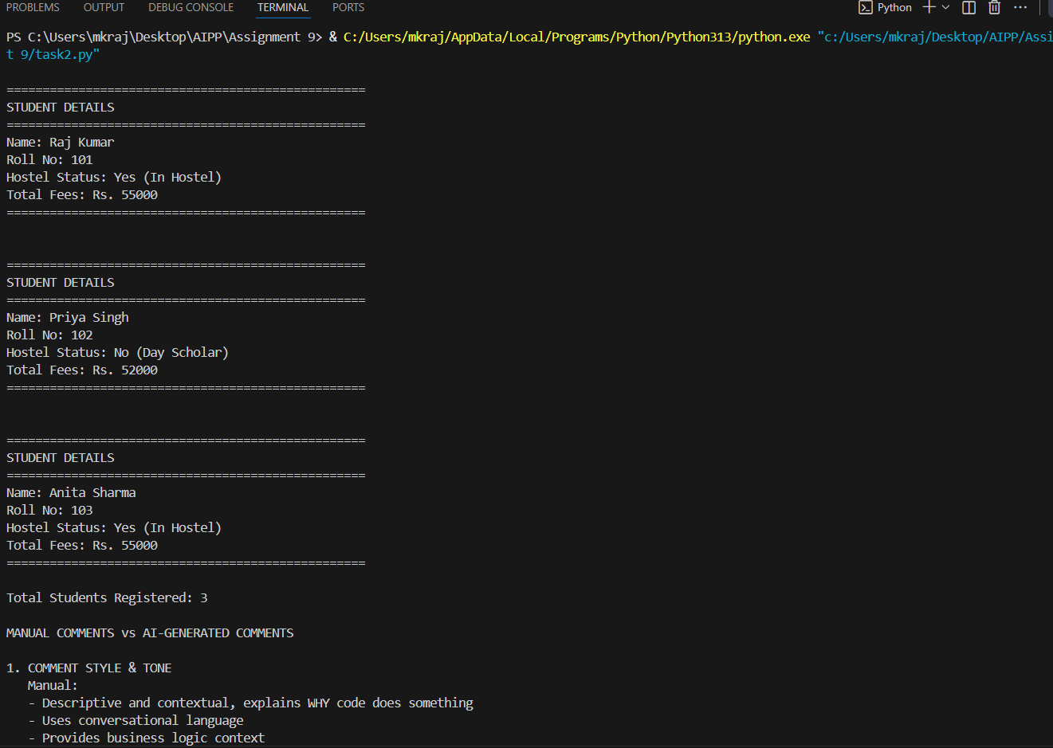  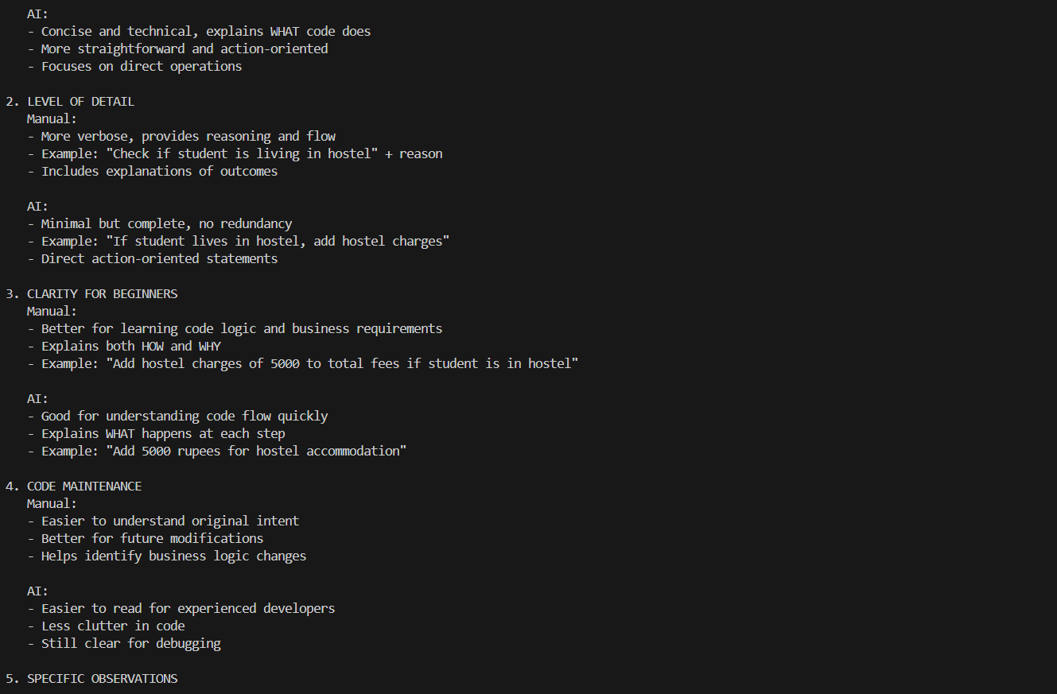  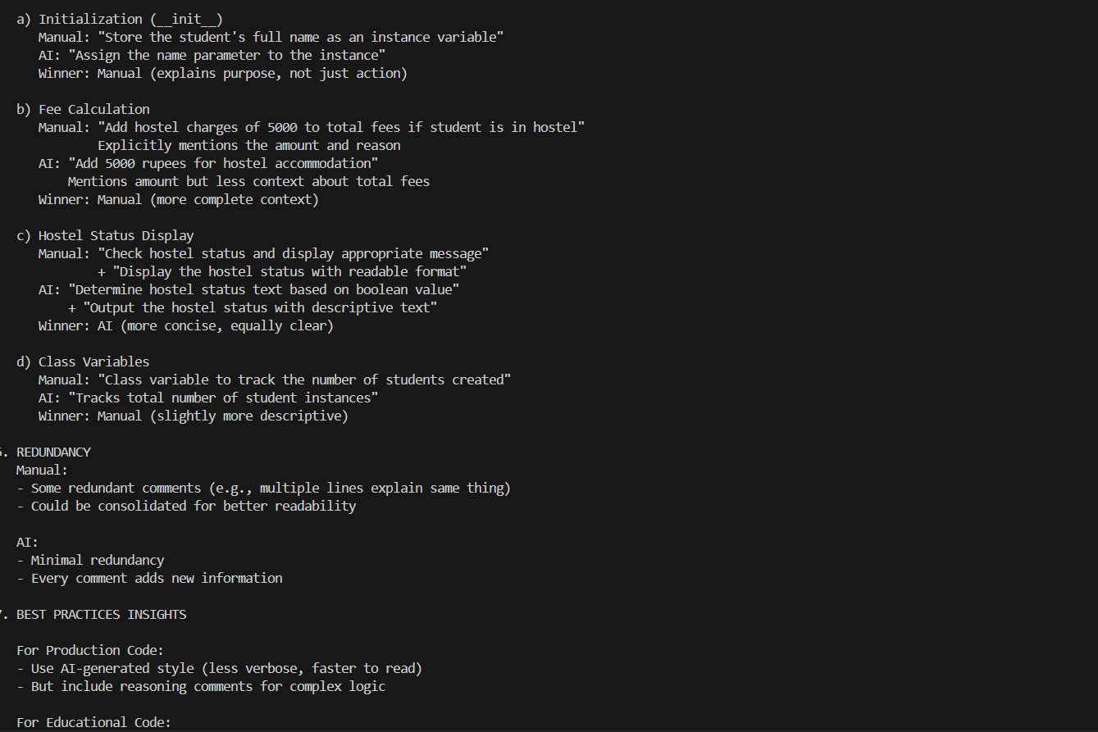  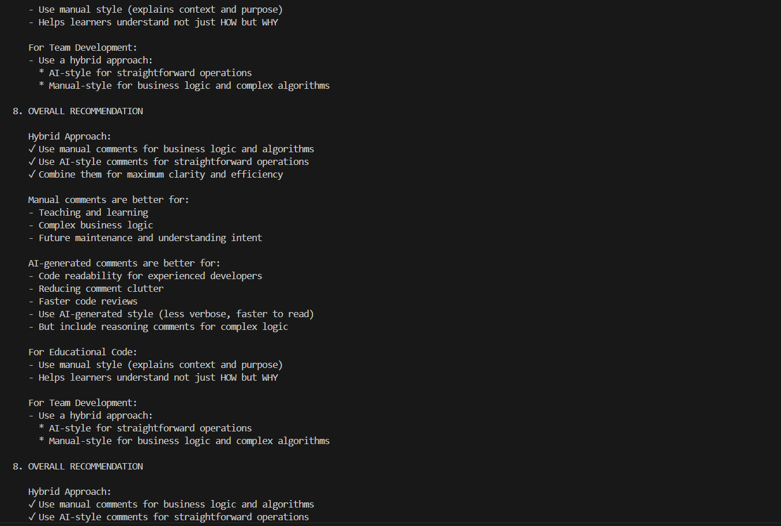  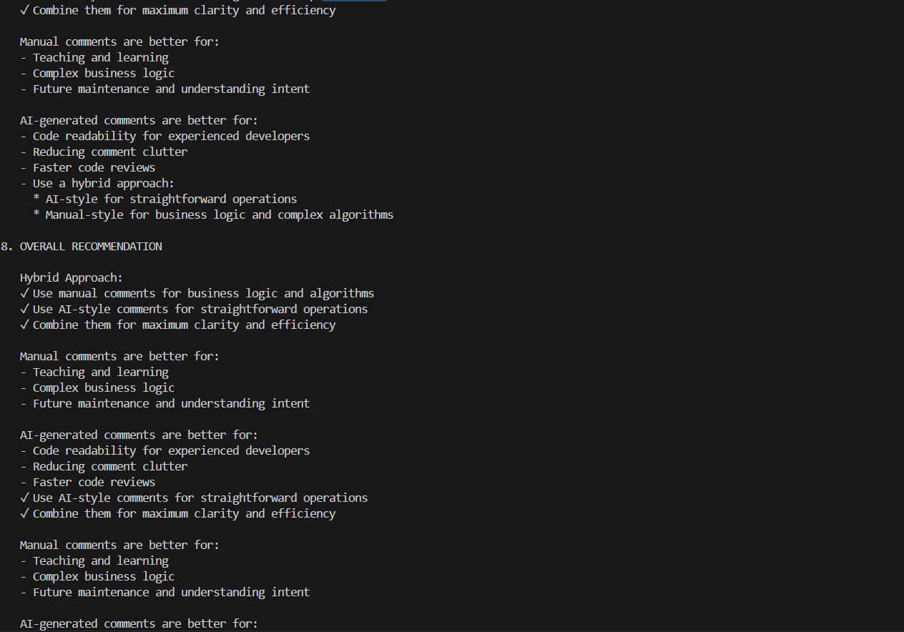  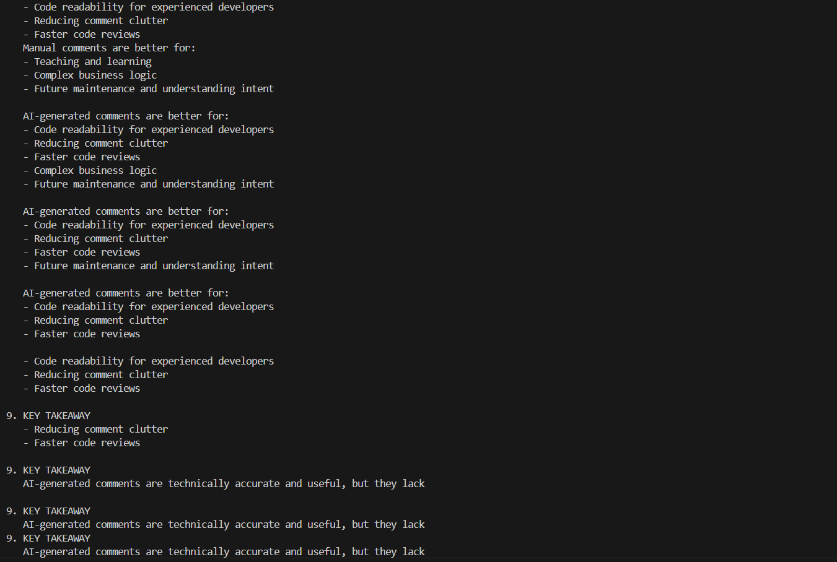  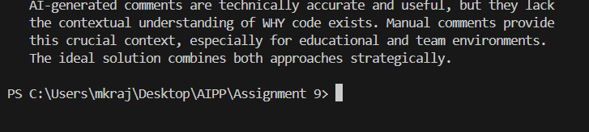  Task Description#3  - Write a Python script with 3–4 functions (e.g., calculator: add, subtract, multiply, divide).  - Incorporate manual docstring in code with NumPy Style  - Use AI assistance to generate a module-level docstring + individual function docstrings.  - Compare the AI-generated docstring with your manually written one.  """  Manual module docstring (NumPy style)  -----------------------------------  A small calculator module that provides four basic arithmetic functions:  `add`, `subtract`, `multiply`, and `divide`.  This module demonstrates structured documentation using the NumPy docstring  style and includes a set of AI-generated docstrings for comparison.  Notes  -----  The AI-generated docstrings are included as separate *_ai functions and  as the variable `ai_module_docstring` so students can compare style,  clarity, and content.  """  # AI-generated module docstring (simulated)  ai_module_docstring = """  AI-generated module docstring (simulated)  ---------------------------------------  Provides basic calculator functions (add, subtract, multiply, divide).  Each function accepts two numeric inputs and returns the arithmetic result.  The AI docstrings focus on succinct explanation and example usage. They are  more narrative and less strictly formatted compared to the manual NumPy  style docstring at the top of this file.  """  # Manual NumPy-style function docstrings and implementations  def add(a, b):  """  Add two numbers.  Parameters  ----------  a : float  First addend.  b : float  Second addend.  Returns  -------  float  The sum of ``a`` and ``b``.  Examples  --------  >>> add(1, 2)  3  """  return a + b  def subtract(a, b):  """  Subtract one number from another.  Parameters  ----------  a : float  Minuend (value to subtract from).  b : float  Subtrahend (value to subtract).  Returns  -------  float  The difference ``a - b``.  Examples  --------  >>> subtract(5, 3)  2  """  return a - b  def multiply(a, b):  """  Multiply two numbers.  Parameters  ----------  a : float  First factor.  b : float  Second factor.  Returns  -------  float  The product ``a * b``.  Examples  --------  >>> multiply(2, 3)  6  """  return a * b  def divide(a, b):  """  Divide one number by another.  Parameters  ----------  a : float  Numerator.  b : float  Denominator.  Returns  -------  float  The quotient ``a / b``.  Raises  ------  ValueError  If ``b`` is zero.  Examples  --------  >>> divide(6, 2)  3.0  """  if b == 0:  raise ValueError("Denominator 'b' cannot be zero.")  return a / b  # AI-generated versions (simulated) with AI-style docstrings  def add_ai(a, b):  """  Adds two numeric values and returns the result.  This function takes two inputs, adds them, and returns the sum. Works  with ints and floats.  Parameters  ----------  a, b : numbers  Operands to add.  Returns  -------  number  Sum of the inputs.  Example  -------  >>> add_ai(1, 2)  3  """  return a + b  def subtract_ai(a, b):  """  Subtracts the second value from the first and returns the difference.  The function performs a straightforward subtraction and returns the  numeric result.  """  return a - b  def multiply_ai(a, b):  """  Multiplies two numbers and returns the product.  """  return a * b  def divide_ai(a, b):  """  Divides a by b and returns the quotient. Raises an error on division  by zero.  """  if b == 0:  raise ValueError("Cannot divide by zero")  return a / b  # Comparison helper  def compare_docstrings(func_manual, func_ai):  """  Compare two functions' docstrings and print a short summary.  Parameters  ----------  func_manual : callable  Function object with manual (NumPy-style) docstring.  func_ai : callable  Function object with AI-generated docstring.  """  dm = func_manual.__doc__ or "(no docstring)"  da = func_ai.__doc__ or "(no docstring)"  print("\n" + "-"*60)  print(f"Comparing docstrings for: {func_manual.__name__} vs {func_ai.__name__}")  print("-"*60)  print("MANUAL (NumPy-style):")  print(dm.strip())  print("\nAI-GENERATED (simulated):")  print(da.strip())  # Very small automated comment-level comparison  print("\nQuick differences:")  len_dm = len(dm)  len_da = len(da)  print(f" - Manual docstring length: {len_dm} characters")  print(f" - AI docstring length: {len_da} characters")  print(" - Manual tends to be more structured (sections).\n - AI tends to be more narrative/concise.")  # Basic tests and demonstration  if __name__ == "__main__":  # Interactive CLI: get two numbers and an operation from the user  def get_number(prompt):  """Prompt repeatedly until the user enters a valid number or quits.  Parameters  ----------  prompt : str  Text shown to the user when asking for input.  Returns  -------  float  The user-provided numeric value.  Raises  ------  SystemExit  If the user types 'q' or 'quit' to exit the program.  """  while True:  s = input(prompt).strip()  if s.lower() in ("q", "quit", "exit"):  print("Exiting interactive calculator.")  raise SystemExit  try:  return float(s)  except ValueError:  print("Invalid number. Please enter a valid numeric value or 'q' to quit.")  ops = {  '+': (add, add_ai),  '-': (subtract, subtract_ai),  '*': (multiply, multiply_ai),  '/': (divide, divide_ai),  }  print("Interactive calculator (type 'q' at any prompt to quit).")  try:  while True:  a = get_number("Enter first number: ")  b = get_number("Enter second number: ")  op = input("Choose operation (+, -, *, /) or type 'doc' to compare docstrings: ").strip()  if op.lower() in ("doc", "compare"):  # Show module-level comparison and function docstring comparisons  print("\nModule-level docstring comparison:")  print("Manual module docstring (first 200 chars):")  print((__doc__ or "").strip()[:200])  print("\nAI-generated module docstring (simulated, first 200 chars):")  print(ai_module_docstring.strip()[:200])  compare_docstrings(add, add_ai)  compare_docstrings(subtract, subtract_ai)  compare_docstrings(multiply, multiply_ai)  compare_docstrings(divide, divide_ai)  continue  if op not in ops:  print("Invalid operation. Choose one of +, -, *, / or 'doc'.")  continue  func_manual, func_ai = ops[op]  try:  result_manual = func_manual(a, b)  except Exception as e:  result_manual = f"Error: {e}"  try:  result_ai = func_ai(a, b)  except Exception as e:  result_ai = f"Error: {e}"  print("\nResults:")  print(f" Manual implementation ({func_manual.__name__}): {result_manual}")  print(f" AI implementation ({func_ai.__name__}): {result_ai}\n")  # Ask whether to continue  cont = input("Perform another operation? (y/n): ").strip().lower()  if cont not in ('y', 'yes'):  print("Goodbye.")  break  except SystemExit:  pass  Expected Output#3: Students learn structured documentation for multi-function scripts  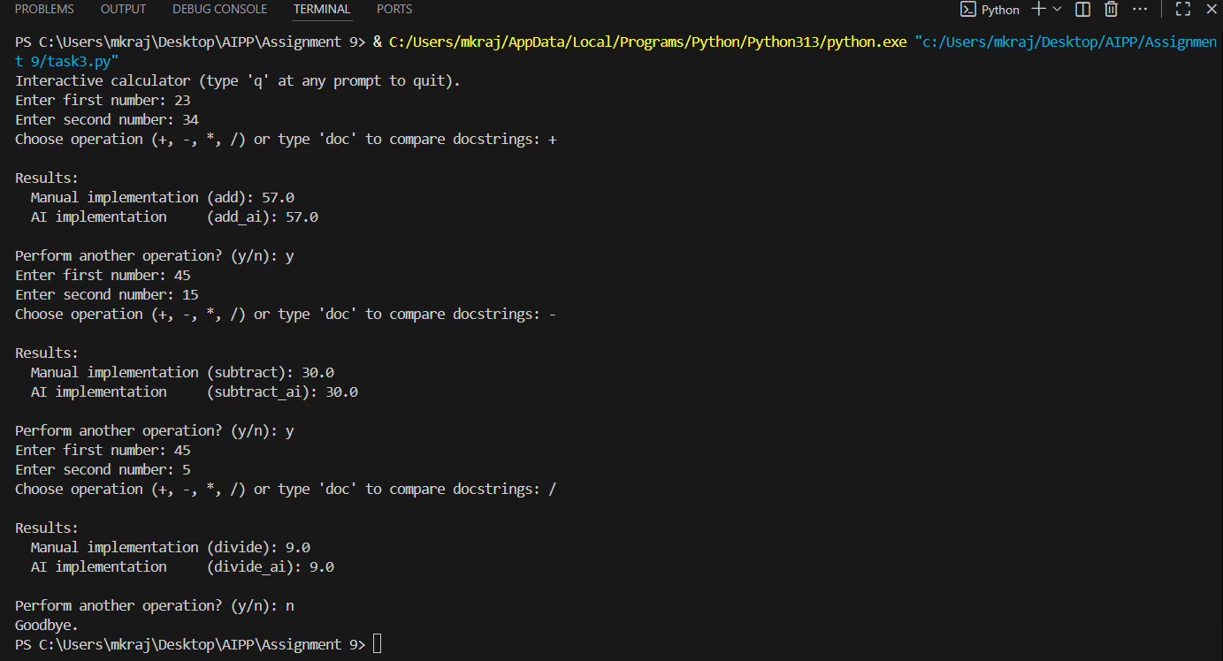  Push documentation whole workspace as .md file in GitHub Repository  Note: Report should be submitted a word document for all tasks in a single document with prompts, comments & code explanation, and output and if required, screenshots |  |  |  |  |  | Week4 - Wednesday

